Two Pointer:
Problem: Reversing the vowels
C++
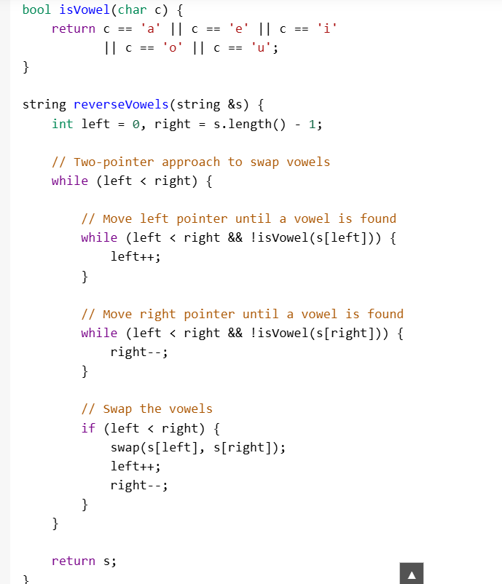

Python:
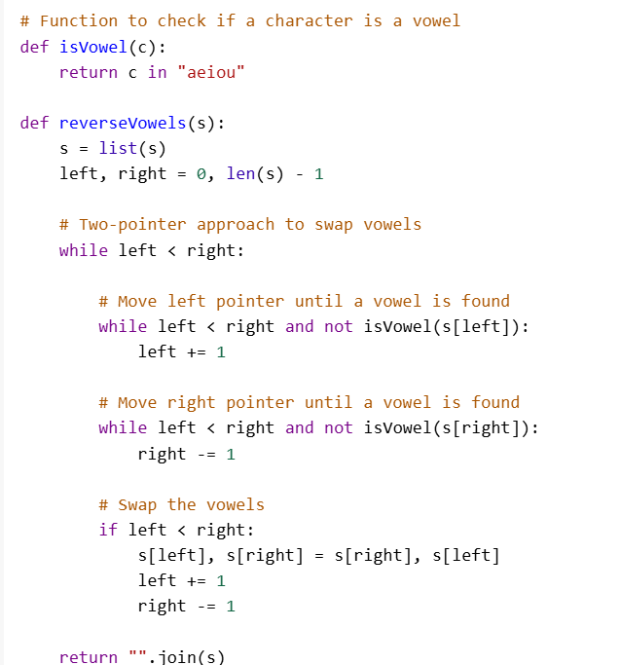

Java:
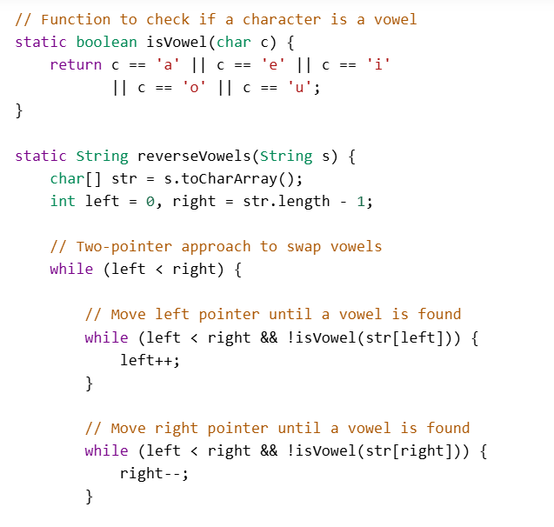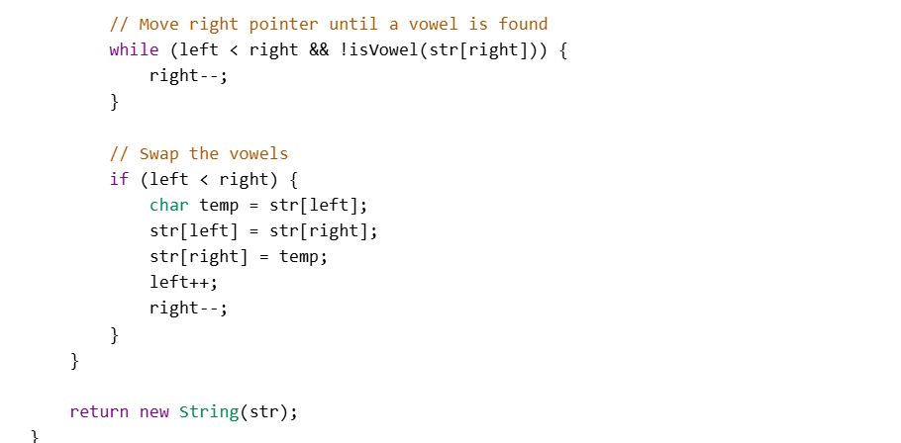

Problem: https://www.geeksforgeeks.org/problems/remove-duplicate-elements-from-sorted-array/1

C++
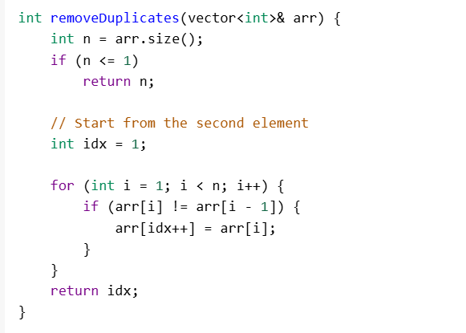
Java:
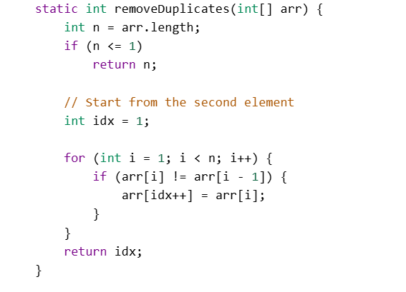

Python:
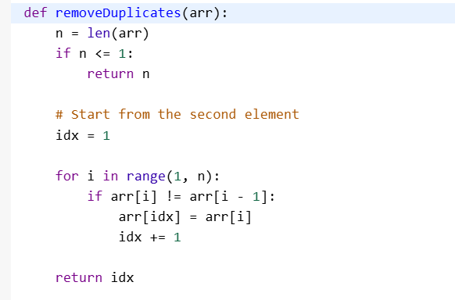

Problem: Two sum Sorted array
https://leetcode.com/problems/two-sum-ii-input-array-is-sorted/description/
C++
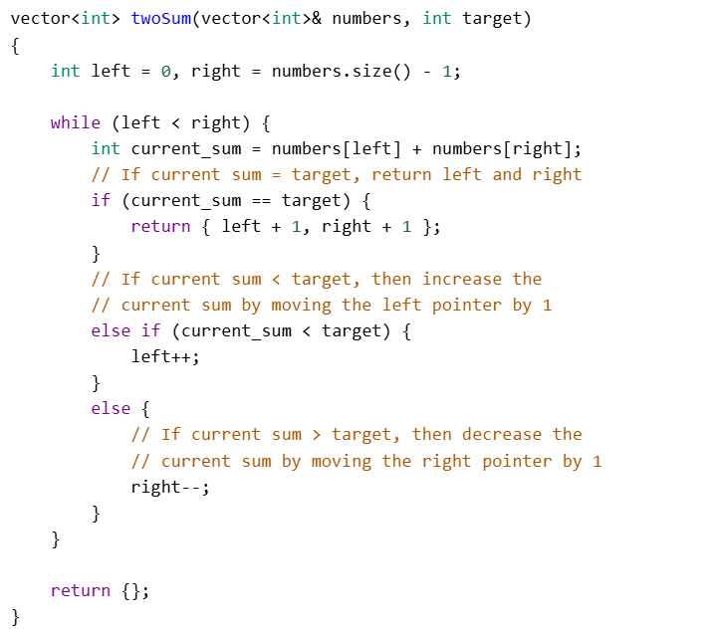

Java:
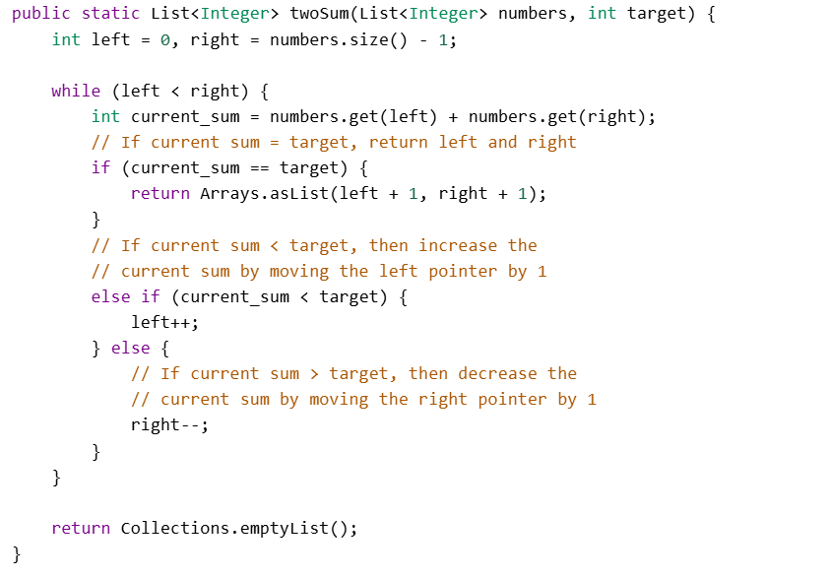
Python:
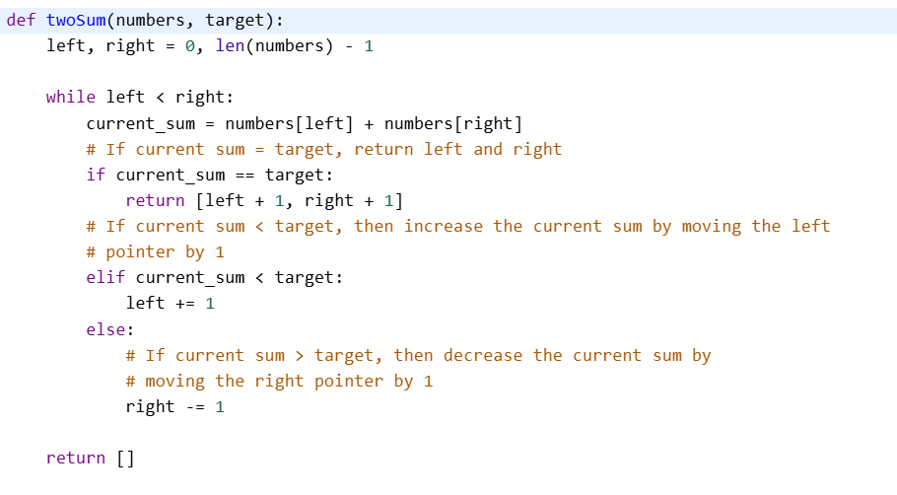

Task: https://leetcode.com/problems/minimize-maximum-pair-sum-in-array/description/
C++
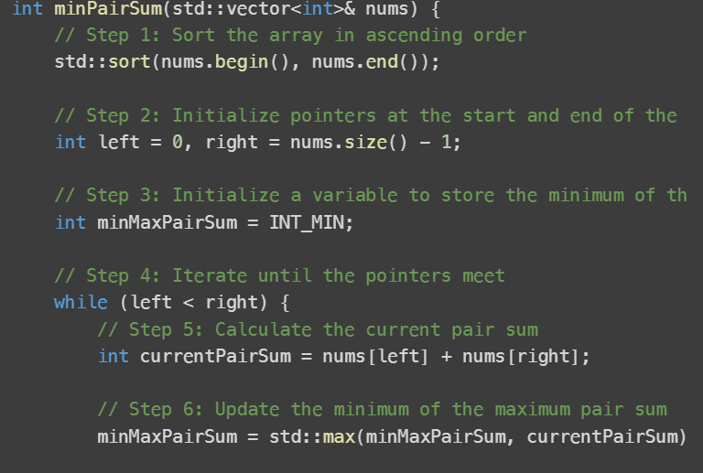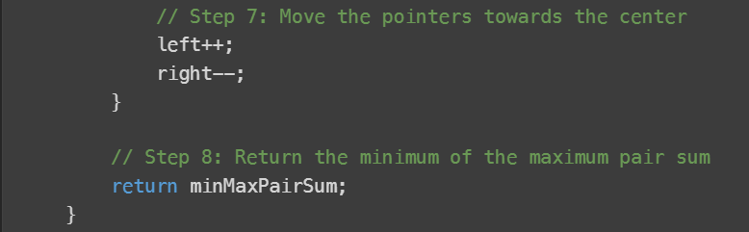

Java:
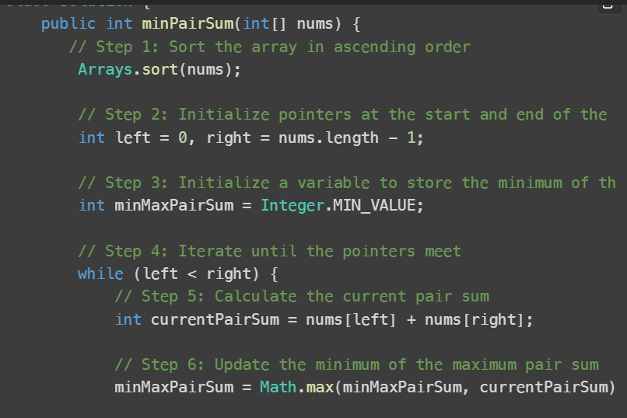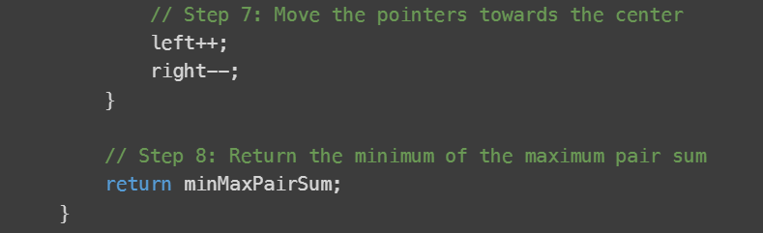

Problem: Container with Most Water
https://www.geeksforgeeks.org/problems/container-with-most-water0535/1
C++
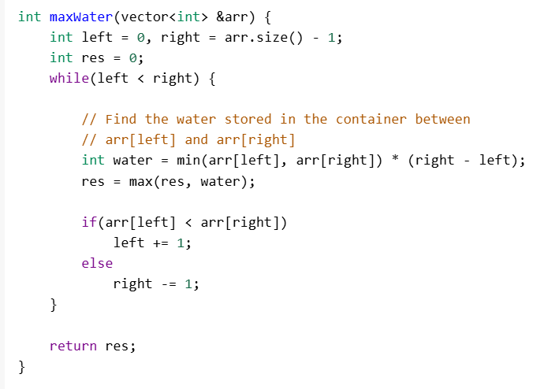
Java:
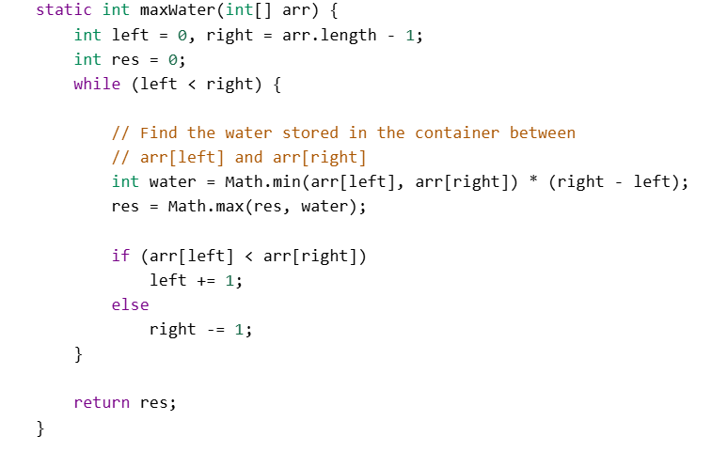
Python:
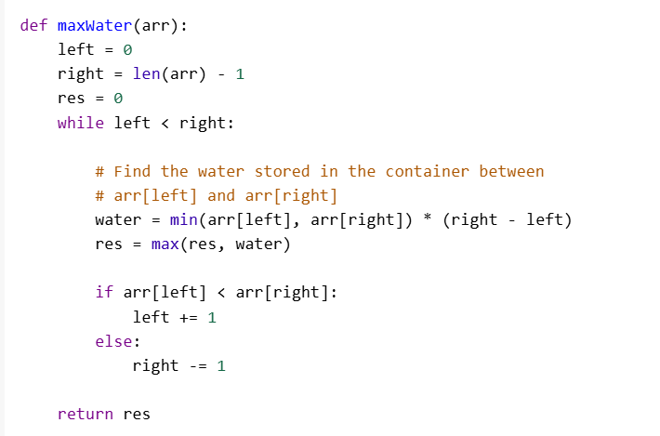

Sliding Window: https://www.geeksforgeeks.org/window-sliding-technique/

Problem:
https://leetcode.com/problems/number-of-sub-arrays-of-size-k-and-average-greater-than-or-equal-to-threshold/description/

C++
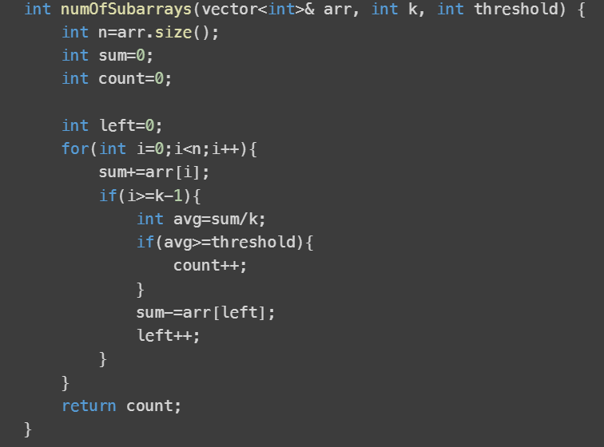

Problem: https://www.geeksforgeeks.org/problems/smallest-subarray-with-sum-greater-than-x5651/1
C++
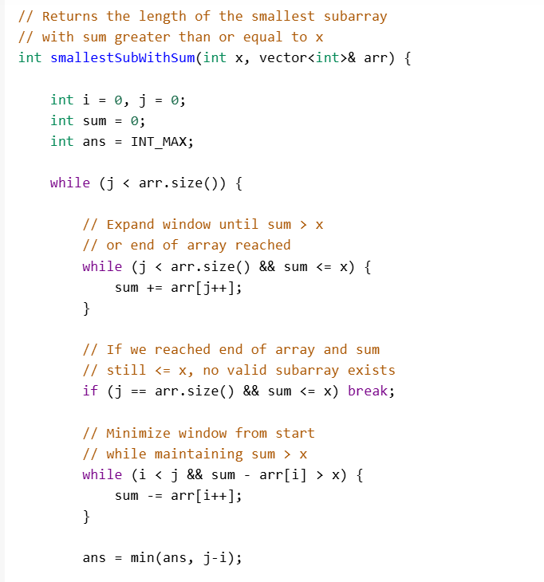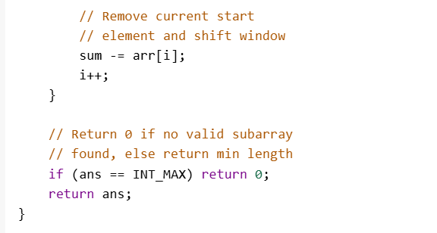

Java:
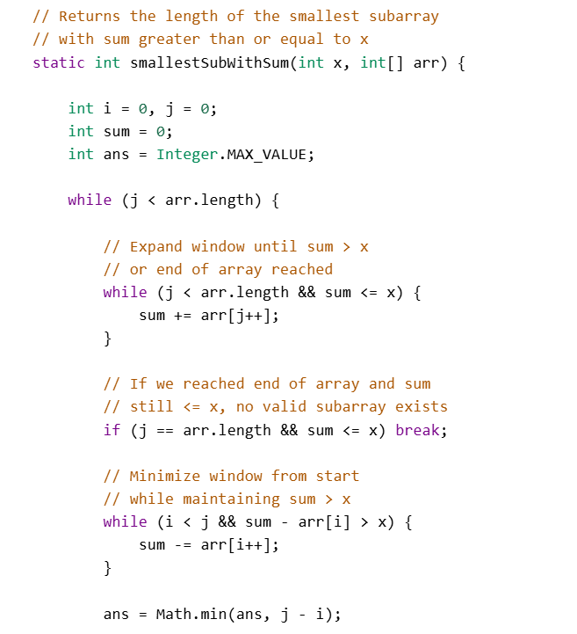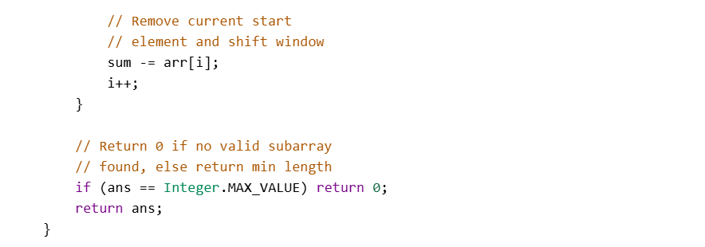
Problem:https://www.geeksforgeeks.org/problems/smallest-distant-window3132/1
C++
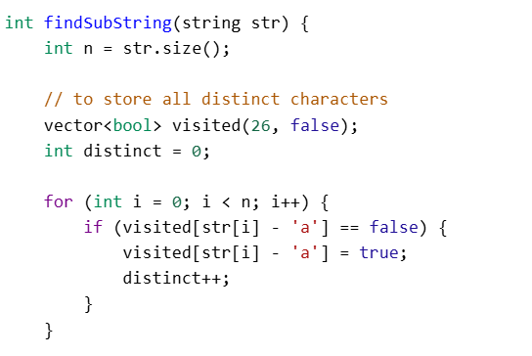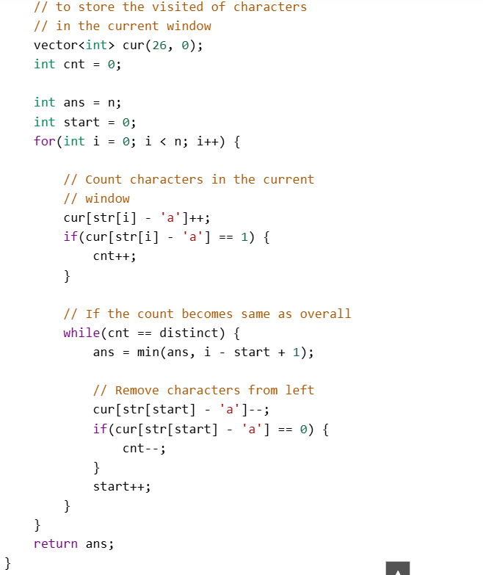
Java:
